**OverTheWire Bandit - Level 6 to Level 7 Writeup**

**Introduction**: This writeup documents my experience solving Levels 6 to 7 of the OverTheWire Bandit challenge, a CTF-style game focused on learning about security concepts.

**Author**: Misha Jain

**Date**: October 19, 2023

**Tools Used:**

Terminal (SSH client)

**Challenge Description:**

Level 6 to Level 7 of Bandit involves connecting to a remote server via SSH and finding a password stored somewhere on the server with specific properties.

**Enumeration:**

For Level 6, we need to connect to the server using the credentials we obtained in Level 5. Our goal is to find a file on the server that meets certain properties, specifically being owned by user ‘bandit7’, owned by group ‘bandit6’, and having a size of 33 bytes.

**Exploitation - Level 6:**

To connect to the server for Level 6 using SSH, we use the provided credentials:

ssh bandit6@bandit.labs.overthewire.org -p 2220

Use the password obtained from Level 5, which is P4L4vucdmLnm8I7Vl7jG1ApGSfjYKqJU to gain access.

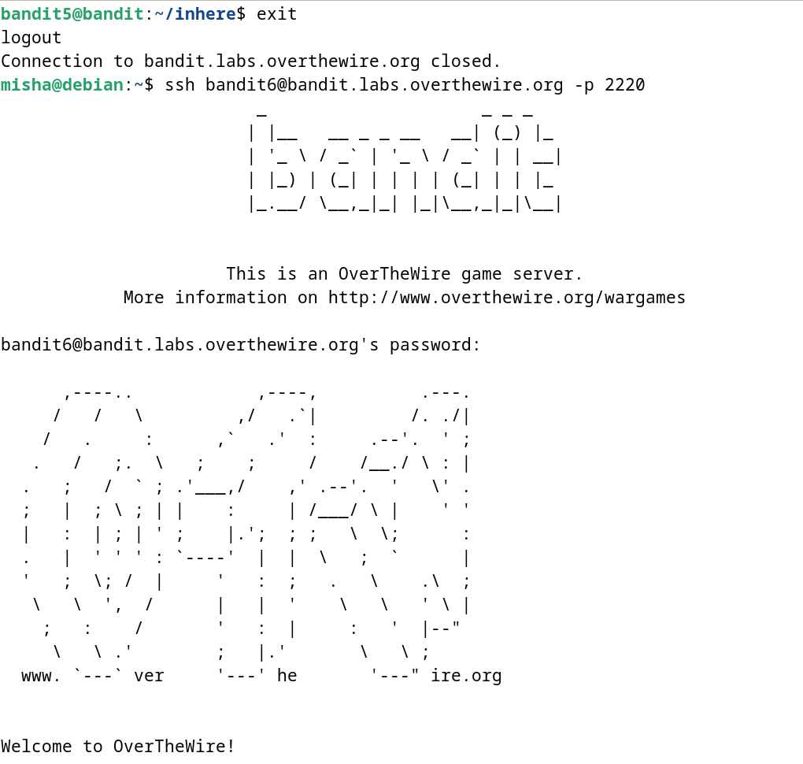

**Password Retrieval - Level 6:**

The password for Level 7 is stored somewhere on the server and has specific properties. To locate this file, we can use the find command with the provided criteria. We'll search for a file that is owned by user ‘bandit7’, owned by group ‘bandit6’, and has a size of 33 bytes:

find / -type f -user bandit7 -group bandit6 -size 33c

‘/’ is used to search for files within the root directory.

After using the find command, we get to know that ‘/var/lib/dpkg/info/bandit7.password’ is the only file that meets the specifications. Hence, we use the cat command to access the contents of /var/lib/dpkg/info/bandit7.password.

cat /var/lib/dpkg/info/bandit7.password

These commands will display the Level 7 password.

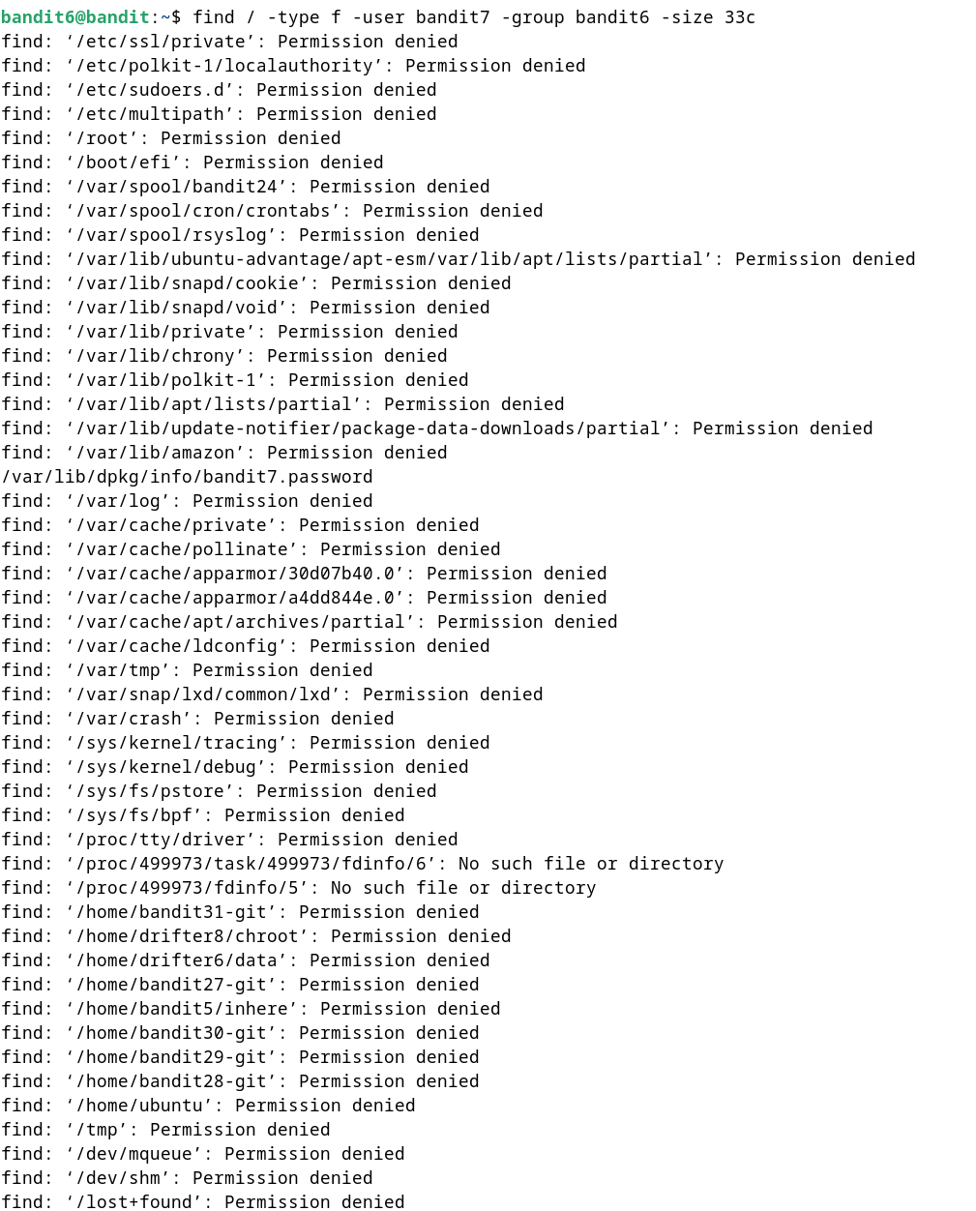



**Password – Level 7:**

The password for Level 7 is: z7WtoNQU2XfjmMtWA8u5rN4vzqu4v99S

**Exploitation – Level 7:**

Now that we have the Level 7 password, we can connect to the server for Level 7 using SSH:

ssh bandit7@bandit.labs.overthewire.org -p 2220

Use the Level 7 password to gain access.

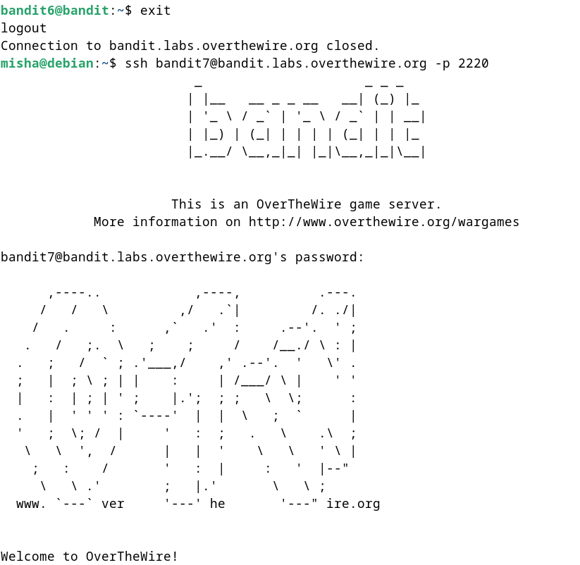

**Lessons Learned:** Level 6 to 7 introduced us to using the find command with various criteria to search for files that meet specific properties. This level reinforced the use of the cat command to read the contents of a file.

**Conclusion:**

Levels 6 to 7 of the OverTheWire Bandit challenge continue to build on shell command knowledge while introducing new challenges involving file properties and searching on a remote server. These levels are suitable for beginners to learn more about working with files and directories.